**User Guide**

This handy guide is here to help you navigate our website like a pro. We will walk you through how to locate all the great sights, organize your trip and keep in touch. Whether you’re on a computer or a phone, this guide is your go-to companion to getting the most of this platform.

**Navigation Bar**

It is the main tool of our website. With it you can reach any point in our website or any page that is desired. For it to appear you have to click on three lines that are on the right of the header. This navigation bar will be present on all webpages of the site.

This only works if you are on a phone. Other than that the items of the navigation are already revealed to you and can be accessed by simply clicking on them.

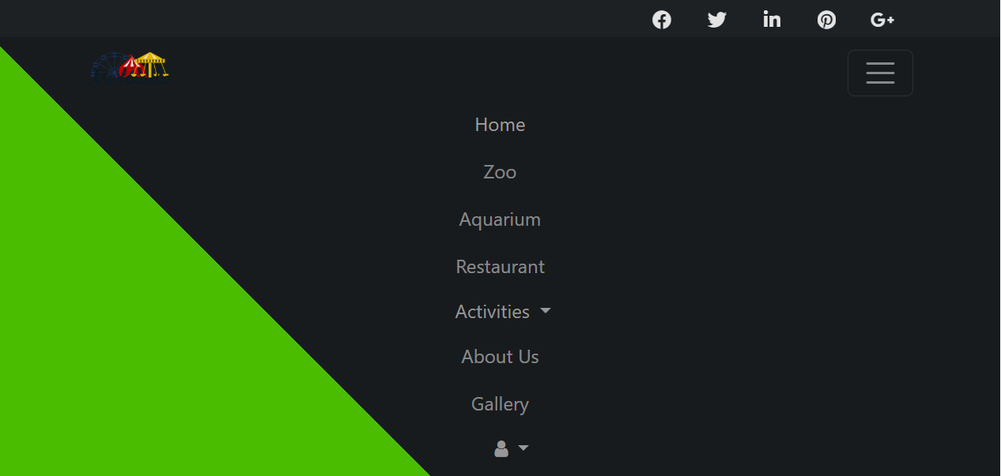

**Homepage:** This page is the face of the website of the park. It has:

* Images of Rides
* Highlights for Galleries
* Sign in Pop Up
* Links to Ticket Booking Section
* Sitemap

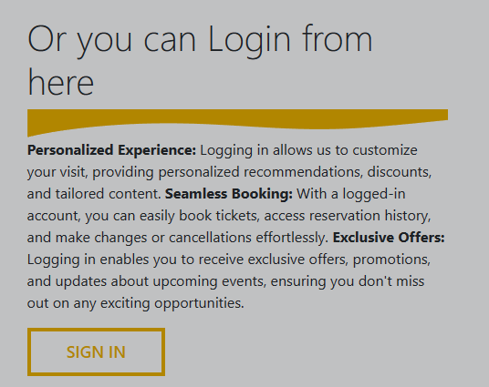To sign in just go to the homepage’s sign in section or you can click on user icon from the navigation bar and pressing “login” button. This will bring up a pop up where you have put your credentials and simply clicking sign in.

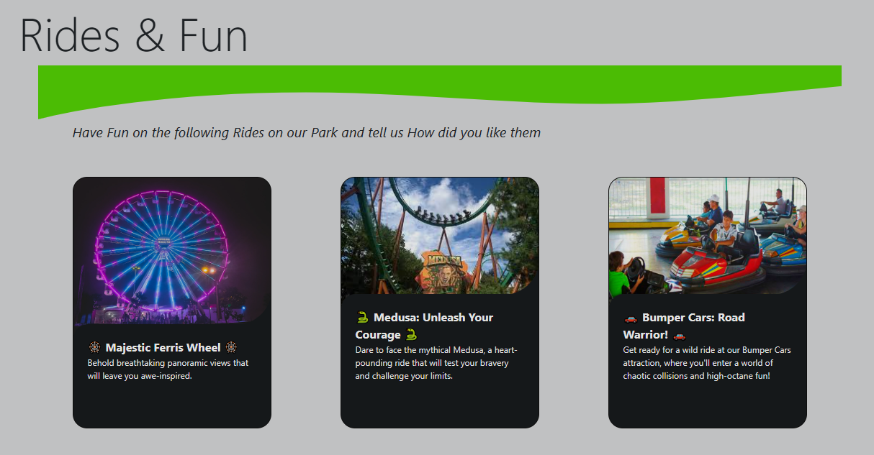Other parts of the website are static but very colorful. You can learn about rides and different areas of the park in the “FUN AND RIDES” section of the homepage.

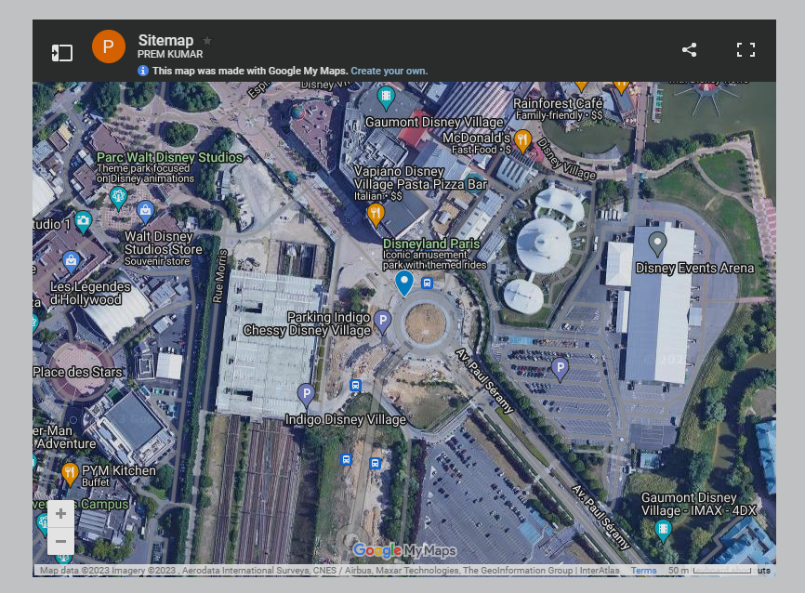To learn about the location and insides of the park, a sitemap has been added for your accessibility. It can be zoomed in, zoomed out or interacted with so you don’t lose your path in the park.

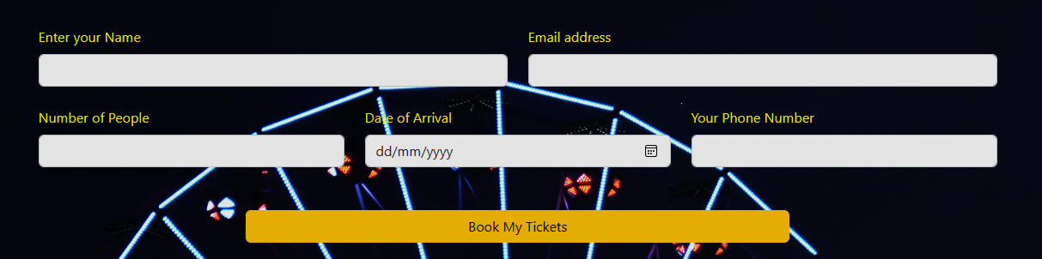**Ticket Booking:** In order to book your tickets for visitation of the park. You can go to the ticket booking section right beside the sign in button. Keep in mind you need to have an account logged in in order to book yourself.

Here you are greeted with short yet easy form to fill. Just provide your details that are asked in the form. The form requires the following information:

* Your Full Name
* Email Address
* Number of people you will bring at the park / Family members
* Your date of arrival
* Your Phone number

All this information is necessary for us in order to register your bookings. After you are done just click the “Book my Tickets” button and you are done.

If you are bringing your family and want a discount you can check the deals that are below the form. They differ in price due to different packages being offered in each of them. You can check them and bring your family and avail them. Here is what a discount card looks like.

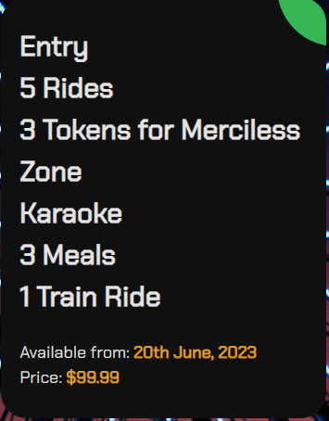

Although the real thrill is upon visiting the park but this website doesn’t leave any stone unturned to showcase the beauty of its wide land. You can visit the Zoo & Aquarium section to know what type of creatures you will find on your visit. Here are some of them:

* Leopards
* Neptune Groupers
* Elephants
* Wrought Iron Butterfly Fish
* Horses
* Seahorses

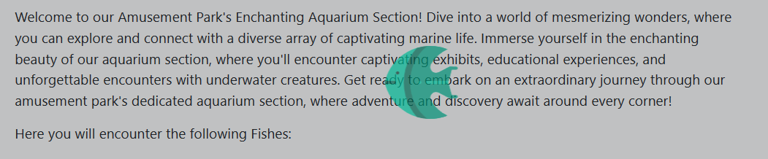

There are little fishes swimming across the webpage to keep you entertained.

**Restaurant:** After Walking so much, you will be tired of course. So here is a place to sit, stay and eat. Tasty bites has a big menu for you to choose from. Food cannot be ordered from this webpage, the restaurant has to be visited to try their delicacies. Here are some foods that they offer:

* Coffee
* Cookies
* Nachos
* Burgers

This page’s colors scheme is very colorful and a lot is told about each food.



They update their menu from time to time so you can always come back and expect something new.

**Gallery:** In a big place like a renowned amusement park, memories will be made. These memories are captured in the form of pictures and saved at our gallery. Just go to the navigation bar and click Gallery to visit this page.

You can not only view them at this page but also send us your memories that you have saved in your heart and we will put them on our display. There is also some text added for the context of the memory. 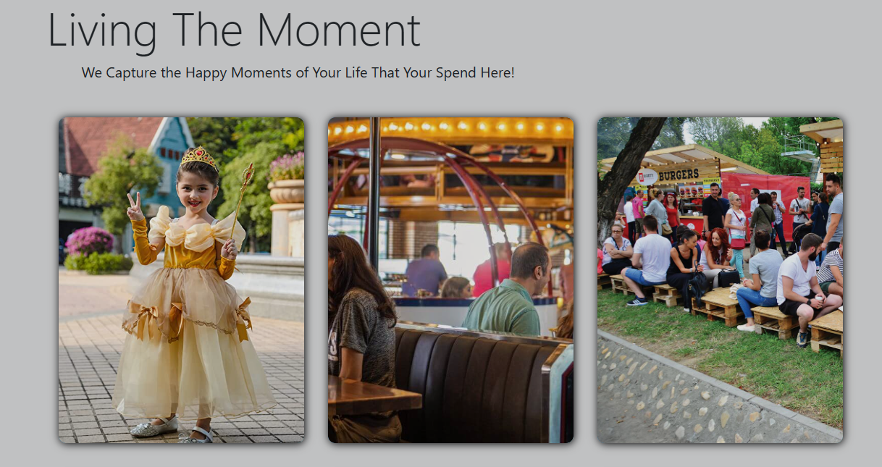

**About Us:** In this page:

* You can know about the website and the creators of this park.
* Terms and Conditions of the park are mentioned.
* Privacy Policy of the park is written clearly.

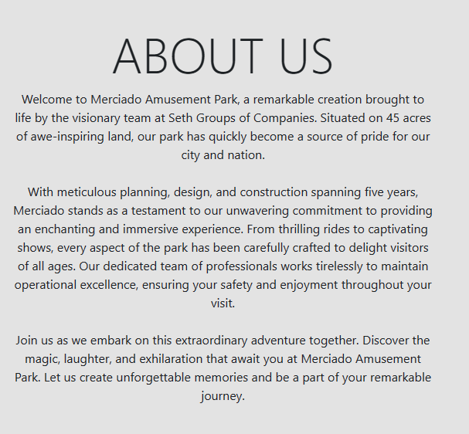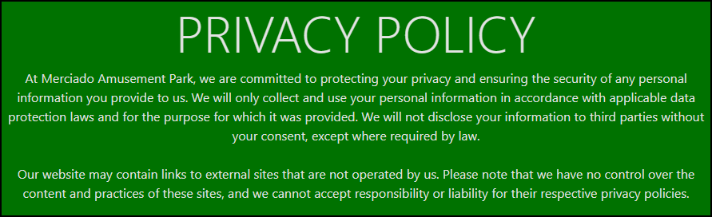

These policies are made in order to make a visitor’s experience as pleasant as possible. So read them before you come here and have as much fun as you want because here, the possibilities are endless.

**Bottom / Footer:** This component is present at the bottom in every page of the website. It has all the quick links for you to click and visit. Not only is it colorful in looks but also responsive.

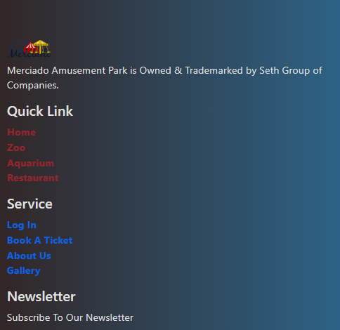It has a newsletter for you to subscribe. Just put your email address and click subscribe. That’s it. One advantage of this is you can get exclusive discounts on your mail from us.

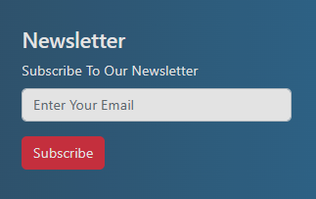

That’s basically it. We really hope that this user manual has improved your visit to the Merciado Amusement Park website. Keep in mind that our website is made to give you all the details you require to organise your trip, learn about the attractions, and remain current with news and activities. Feel free to contact our helpful support staff if you have any additional queries or require assistance. Get ready to create unforgettable memories at Merciado Amusement Park, where excitement and wonder await at every turn. Thank you for choosing us as your destination of fun and adventure. Enjoy your time exploring our website and we can't wait to welcome you to the park!

**THANK YOU!**